

AR8621/AR8622 AC MOTOR CONTROL SYSTEM
AR8621/AR8622 motor control system has wireless receive function and outside control connect port，can work together with switches, RF transmitters and outside control equipments. It is adapted for all kinds of single-phase AC curtain motors, tubular motors, projection screen motors and roller shutter motors, and so on.

Attention
Please read this specification carefully before installing.
Please check if the motor power and current fit for the product requirement.
To ensure safe, please install this product by professional person.

Product standard

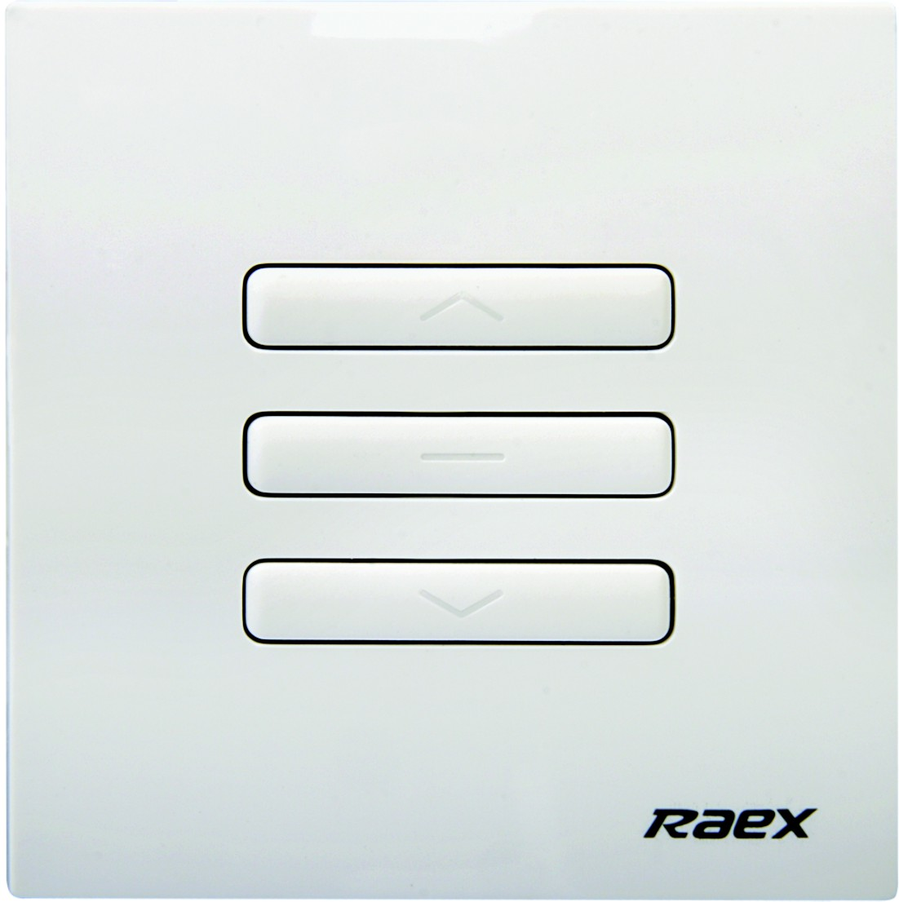 | AR8621 one channel controller  Rating voltage: 220-240V, 50/60Hz  Rating current: 4A  Receive modulate: 447.70MHz，ASK  Control channel: at most 16codes
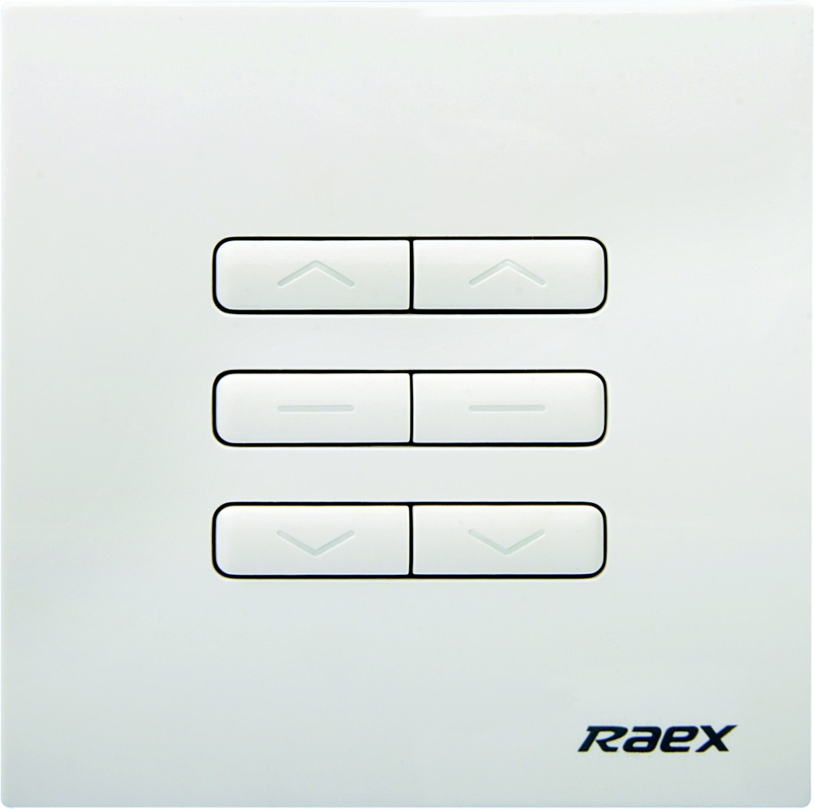 | AR8622 double channel controller  Rating Voltage: 220-240V, 50/60Hz  Rating current: two channels 4A  Receive modulate: 447.70MHz，ASK  Control channel: Each channel at most 16 codes
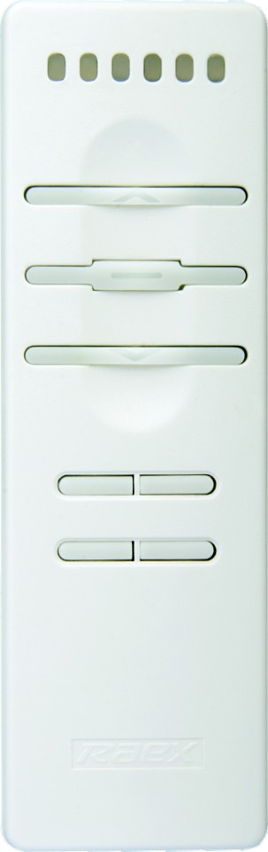 | YR1326 seven channel transmitter  Transmit modulate: 447.70MHz，ASK  Transmit intensity: +10dBm（available range 30m）  Remote channel: seven channels  Battery: CR2032×1
Wire connection
Please connect the cable and motor as below.
AR8621 AR8622
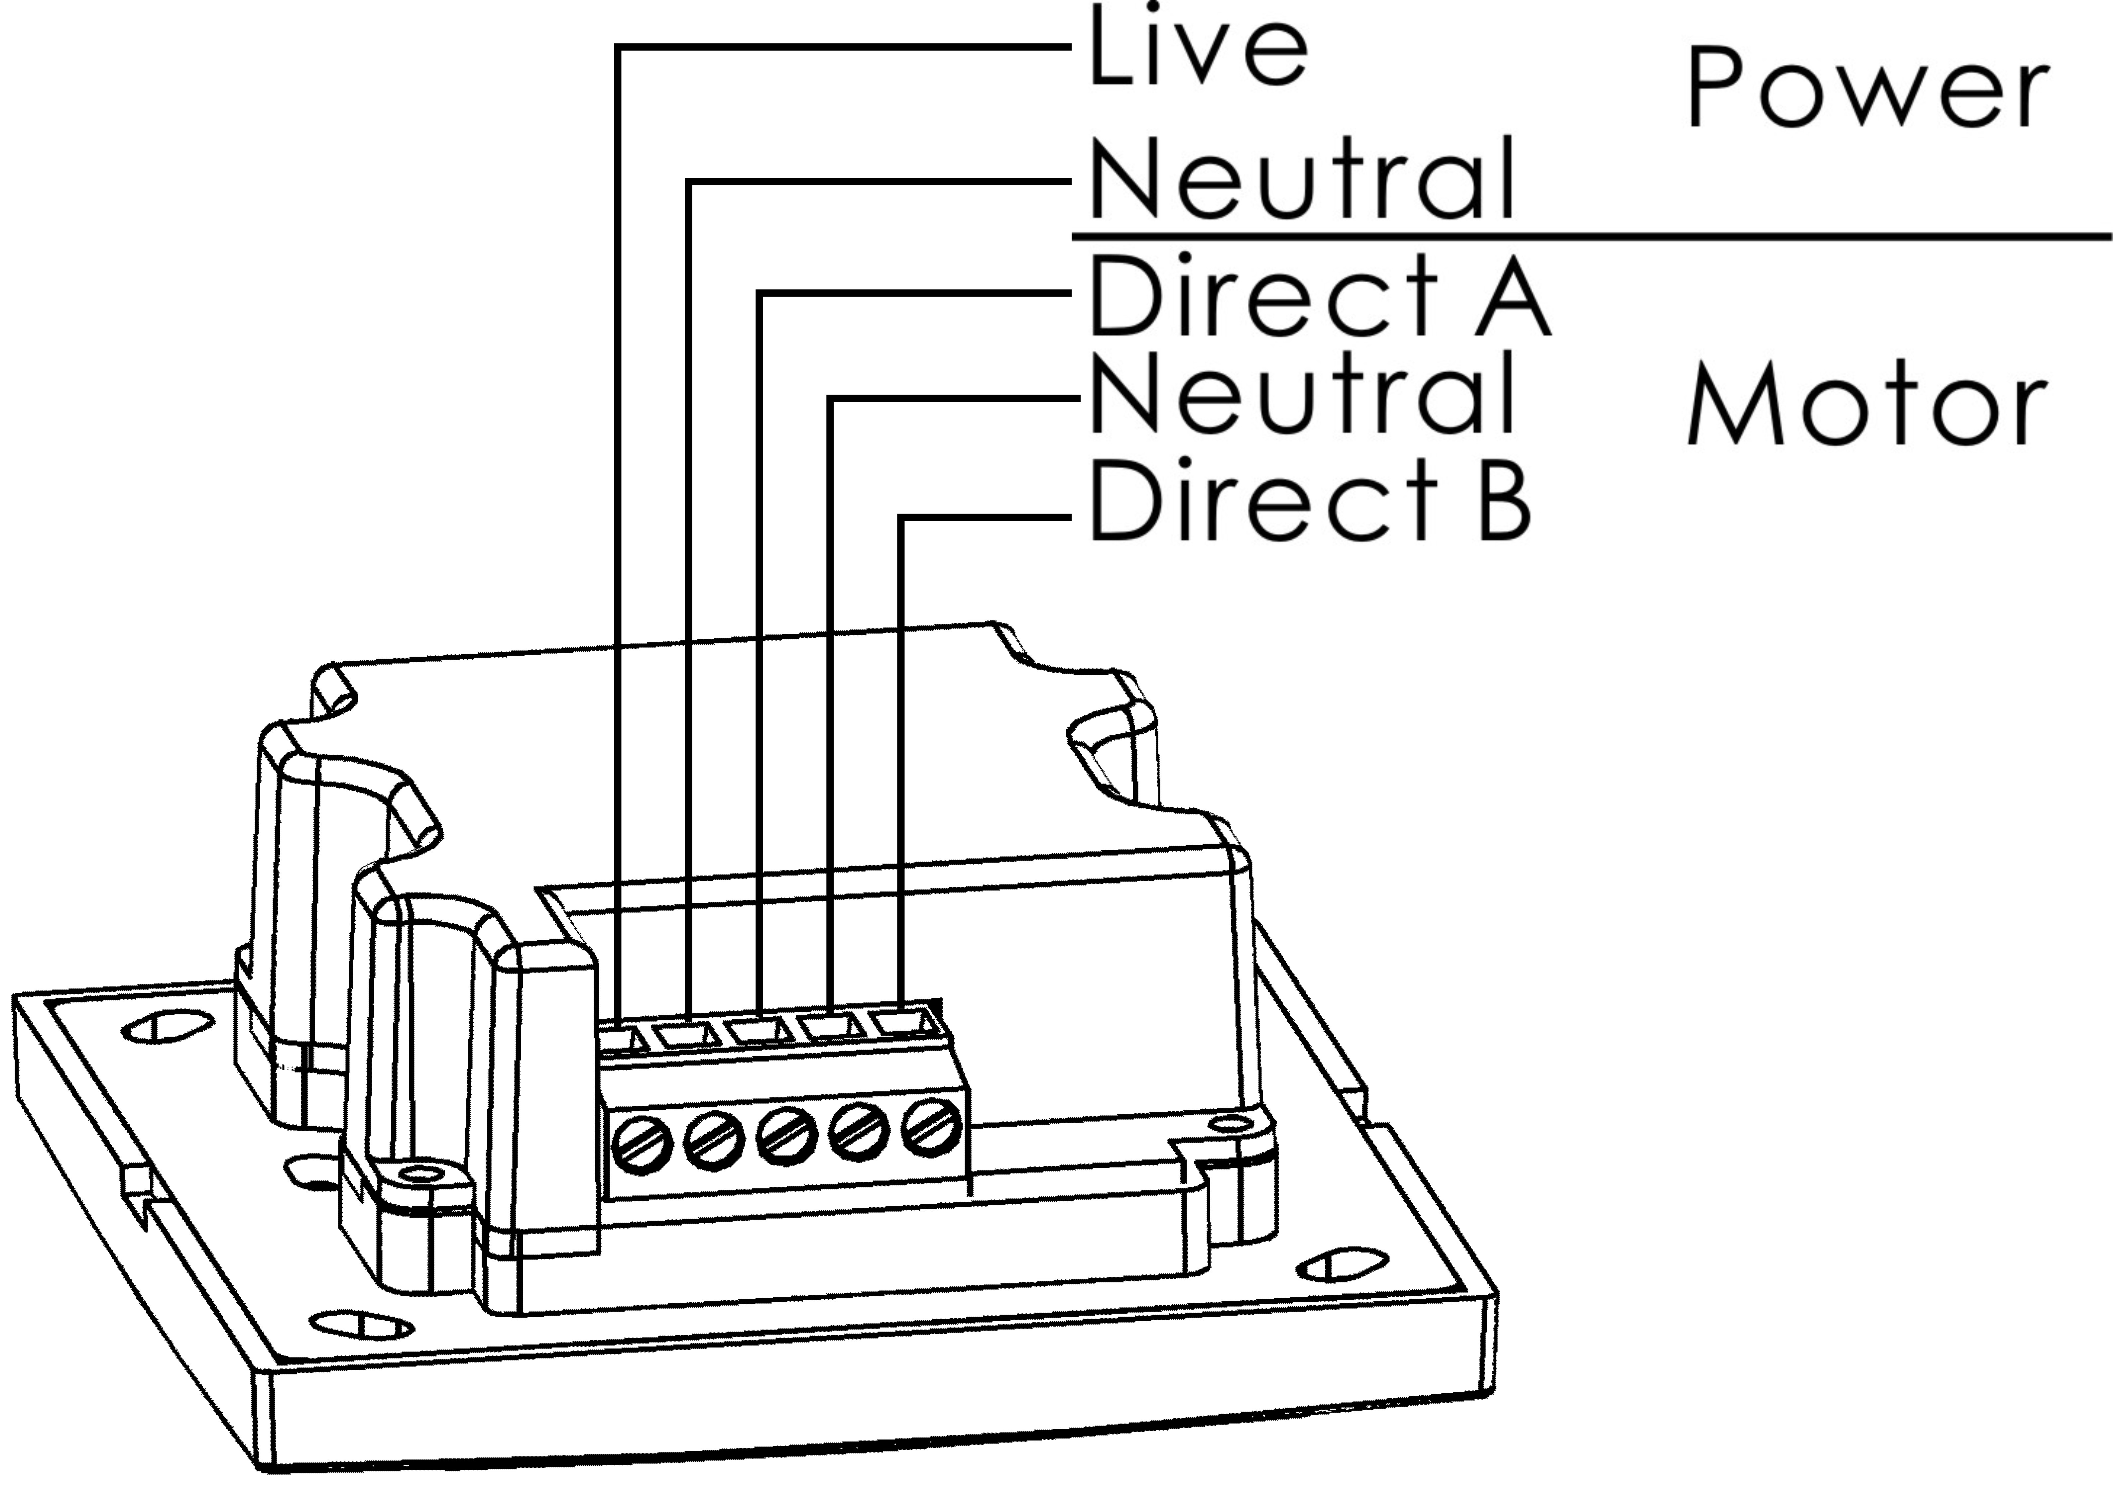 | 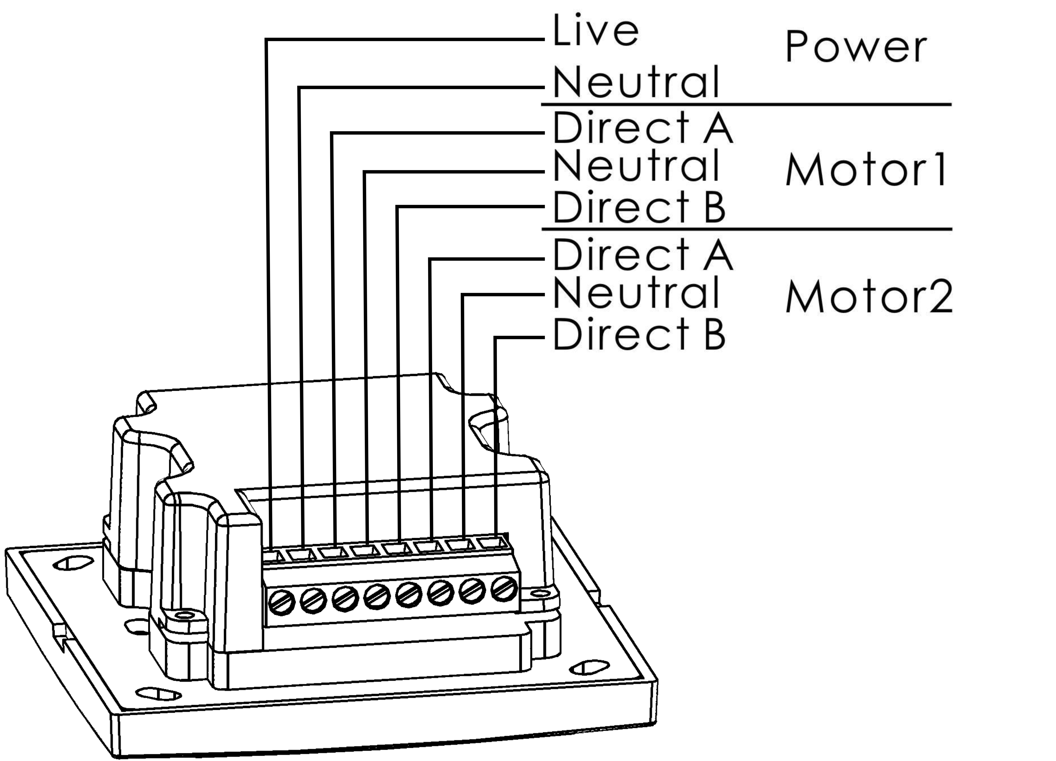

Panel Function
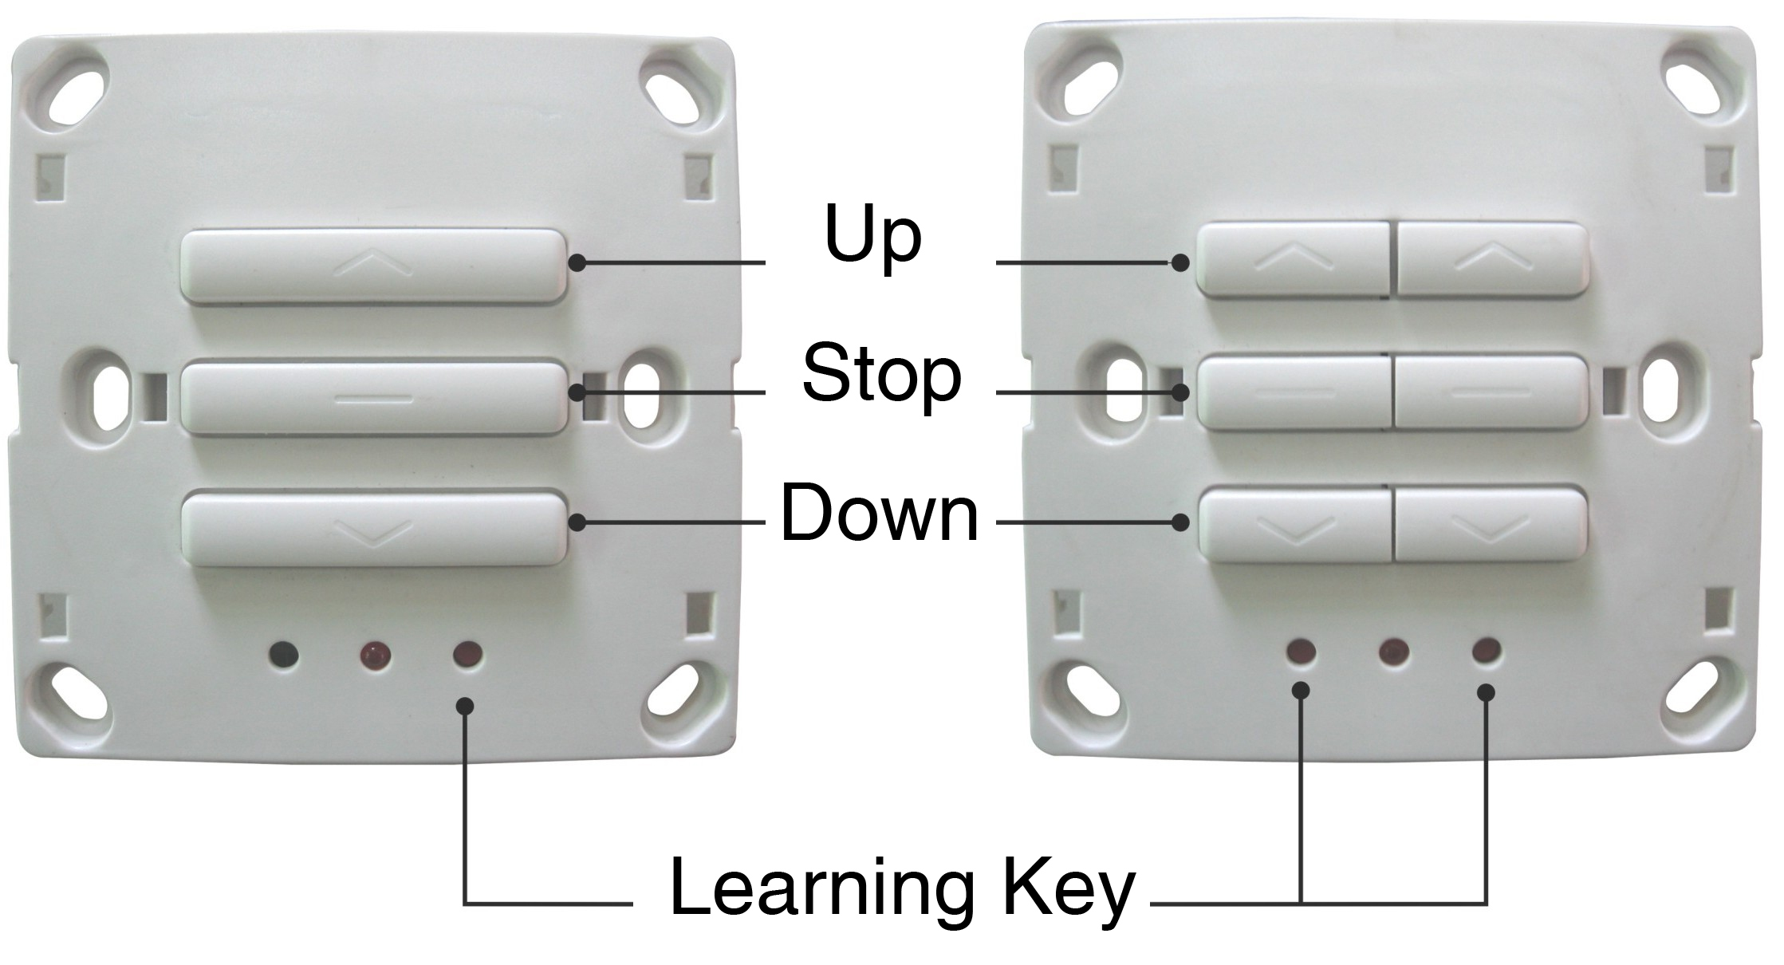
Press [UP] [DOWN] button short time (within 1 second), motor will move discontinuously, and will stop when leave go of.
Press [UP] [DOWN] button more than 1 second, motor will move continuously. The control will cut off the power automatically after 6 minutes.
Press [STOP] button any time, motor will stop to work.
[Learning] key is under the cover of controller and is only used to set remote channel. Please do not use it in common case.

Transmitter
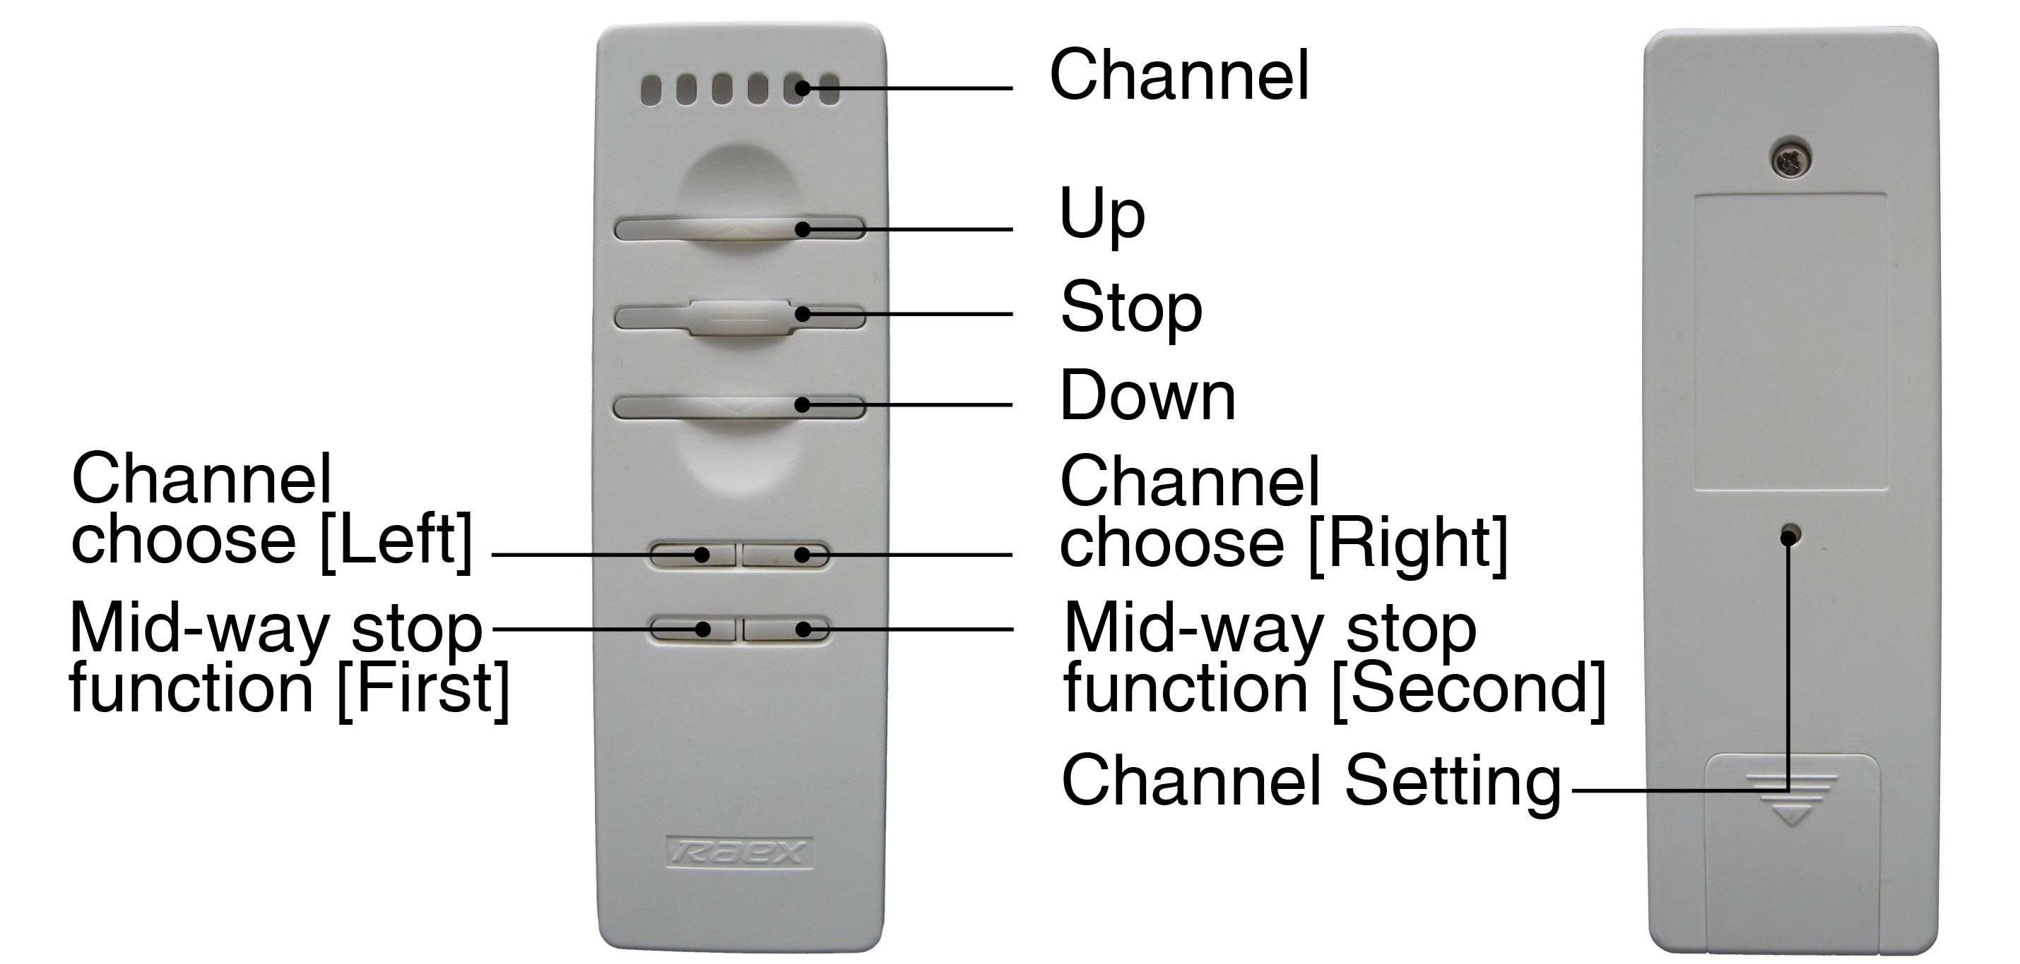
YR1326 transmitter has seven channels, each light is one channel, and six lights flash at the same time means the seventh channel.
Press [channel choose] button to change different channels circularly.
Transmitter will return to the first channel automatically when without any operation within 25 seconds. (This function will help consumer default the first channel every time.)
[UP] [STOP] [DOWN] button separately transmit signals. ([UP] [DOWN] button of transmitter can’t control motors to work discontinuously.)
[Channel setting] key is only used to set remote channel. Please do not use it in general conditions.

Remote control setting
Users must set remote channel and be sure that the transmit signals were recorded in the receiver before using. It can take appropriate actions when the controller receives the remote signal.
If you want to reset all the channels, please delete the remote channels.
When the working direction of the motor is different from the control direction, you needn’t change the cable connection. You can only correct the direction on the transmitter.
Set the remote channel
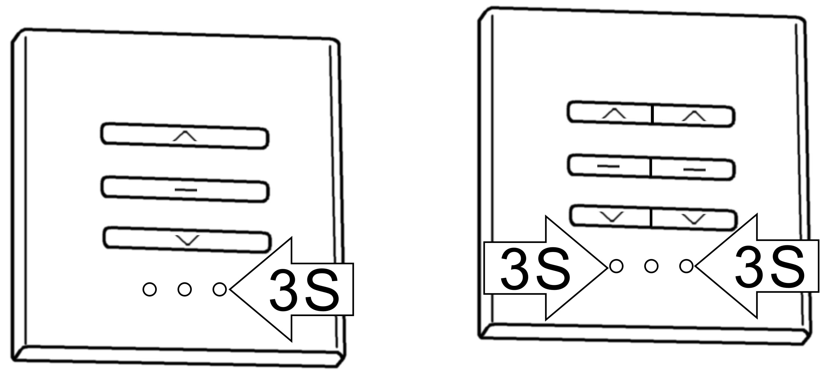 | 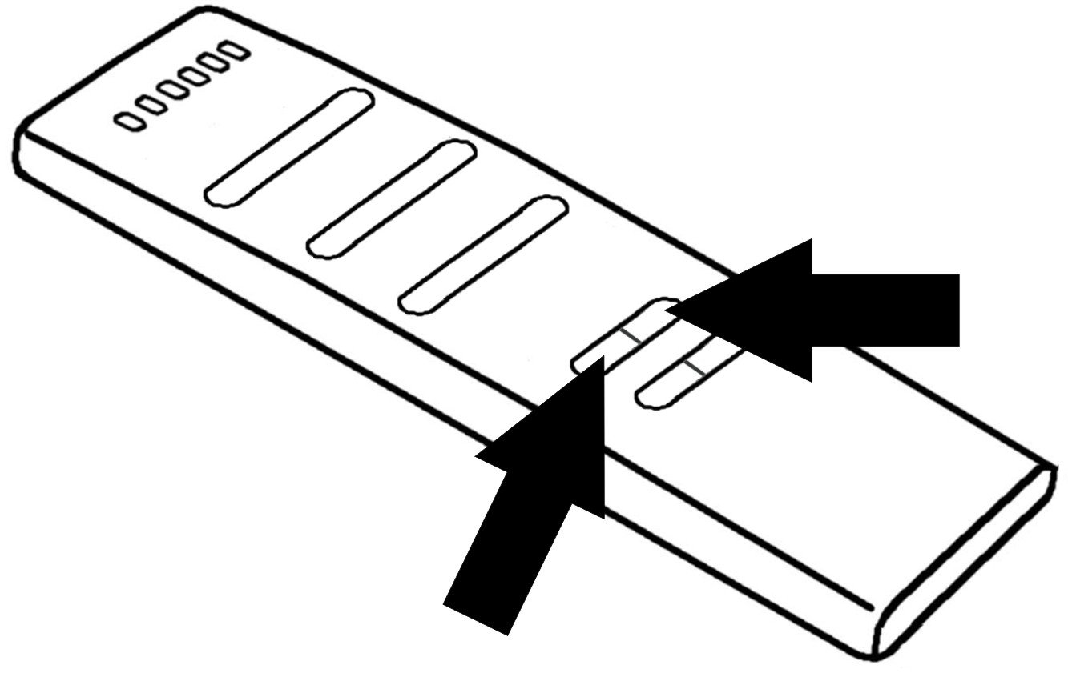 | 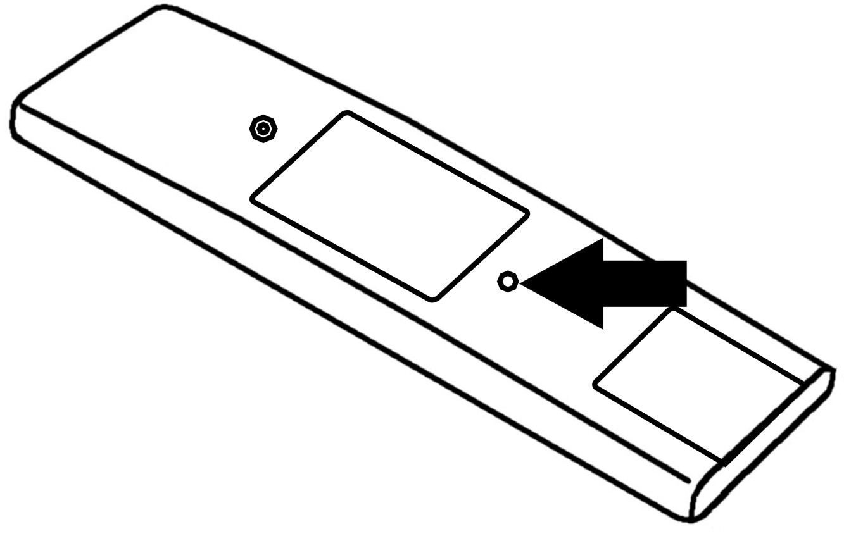
1．Press [Learning] key 3 seconds till the light is on, the controller enters into learning condition. | 2．Press [channel choose] button on the transmitter when you choose the needed channel | 3．Press the [channel setting] key on the back of the transmitter. The channel will be recorded.

Delete remote channel
 | 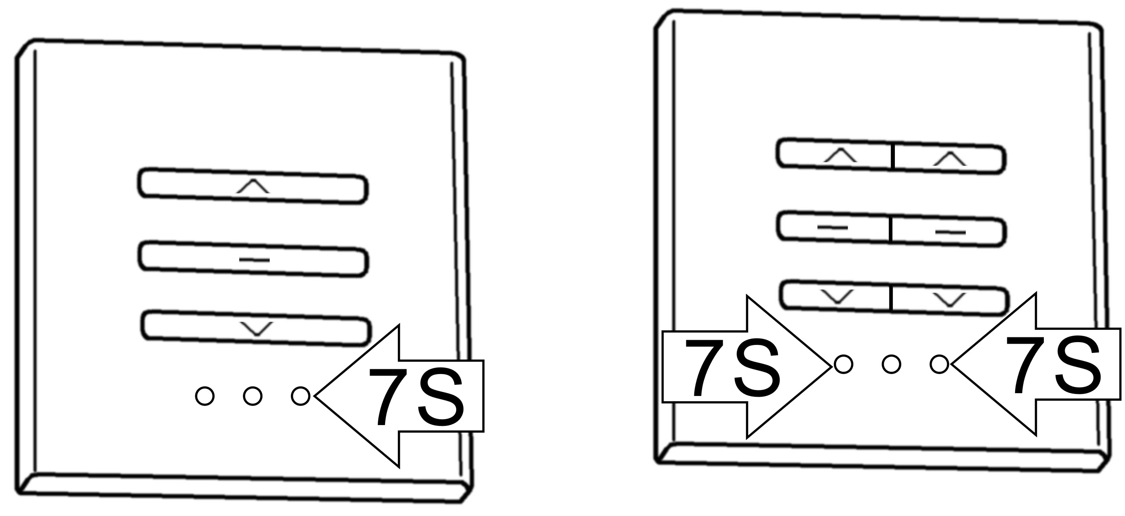
1．Press [learning] key 3 seconds till the light is on. The controller enters into record state. | 2．Re-press [learning] key 7 seconds till the light is off.（Press left or right [Stop] button.  Attn：AR8621 needn’t this step）.

Correct the direction
 | 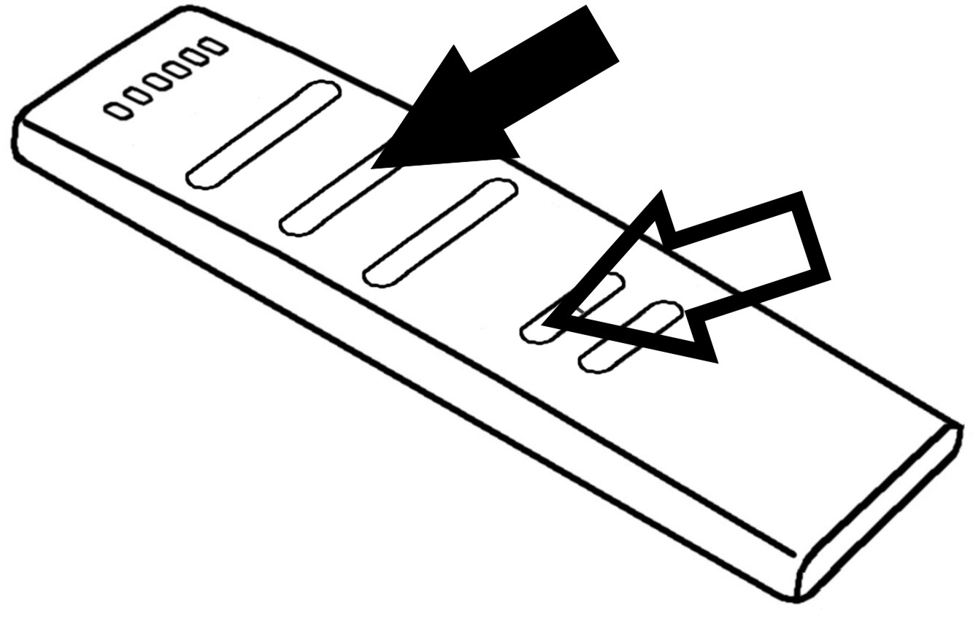
1．Press [learning] key 3 seconds till the light is on. The controller enters into record state. （Press left or right [Stop] button.  Attn：AR8621 needn’t this step.） | 2．Press [channel choose] button, do not loose, then press [Stop] button one time.

Common malfunction

Malfunction | Reason | Settle ways
Controller no reaction | No power supply | Check the power supply is normal or not
Transmitter no reaction | Battery is low power | Change battery
Remote control is ineffective. | Use wrong channel | Re-choose channel, or re-set channel
Remote control is not sensitive. | Battery is low power | Change battery
Remote control is not sensitive. | Control distance is too far | Please use the remote control in the control range
Controller is not normal | Cut the power one minute, make the controller work again.
Other malfunction | Please contact dealers

Warranty period
86 series wireless controllers carry a 5 warranty from the date of manufacture
Factitious damage and dismantle are exclusive of warranty.

